Lab 7
Basic Switch Operation
Objective:
The purpose of this lab is for the student to understand basic switch functionality. Students will also utilize IOS commands to explore switch functionality and features.

Diagram:

Components:
6 – PC’s with an Ethernet NIC
1 – Switch

Procedure:
- Connect all PC’s and the server together and put their static IP addresses on them. The server is just the machine that’ll run an application later. Each PC has this application on the desktop so just choose one. Verify connectivity by pinging each machine. Connect the PCs to ports 1 thru 7. This will help in a later step.

- Connect one PC to the switch via a console cable.

  - What type of connectors are on each end of the cable?
____RJ45______________________________________
____DB9/Serial______________________________________

- Execute the Putty program.

- What are the serial port settings needed to connect to the switch?

Bits per second 9600
Data Bits 8
Parity None
Stop Bits 1
Flow Control None
- What is the first prompt you see when you connect?
Switch>

- Get to the privileged exec prompt.

  - What command did you enter? enable
  - What does the prompt look like? Switch#

- View the running configuration.

  - What command did you enter? show running-config

- View the switches IOS versions.

  - What command did you enter? show version
  - What IOS version is the switch using? [Denali] Version 16.3.7

- View the status of all the interfaces.

  - What command did you enter? show interface status

- View the status of FastEthernet0/1.

  - What command did you enter? show interface fastethernet0/1

- View the CAM table.

  - What command did you enter? show mac address-table
  - List the CAM entries for ports FastEthernet0/1 – 7
  - Take a picture or screen shot.
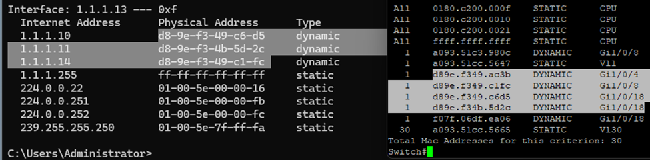
  - Do they match the MAC addresses of the PC’s? Yes!

- Change to global configuration mode.

  - What command did you enter? configure terminal

- Change the switches hostname to Network-1.

  - What command did you enter? hostname Network-1
  - What does the prompt look like? Network1 (config) #
  - Change the hostname back to the default name.
  - What command did you enter? no hostname Network-1

- Select interface FastEthernet0/1.

  - What command did you enter? interface fastethernet0/1
  - What does the prompt look like? Switch(config-If) #

- Set the interface speed to 100.

  - What command did you enter? speed 100

- Set the interface duplex to full.

  - What command did you enter? duplex full

- Go back to global configuration mode.

  - What command did you enter? exit

- Select interface FastEthernet0/2

- Turn the interface off

  - What command did you enter? shutdown

- Select interface FastEthernet0/3

  - Turn the interface off

- View the running configuration mode.

- List the extra commands under interfaces FastEthernet0/1 – 3 that are different from FastEthernet 0/4 in the running-config.

FastEthernet0/1
Speed 100
Duplex full

FastEthernet0/2
shutdown

FastEthernet0/3
shutdown

- Go to interface FastEthernet0/2 and turn the interface on

  - What command did you enter? no shutdown

- Select interface VLAN 1. Turn the interface on.

- Put an IP address of 1.1.1.2 with a subnet mask of /24 on the interface.

  - What command did you enter? ip address 1.1.1.2 255.255.255.0

- Verify connectivity by pinging the switches IP address from a PC.

- Turn on the TFTP service on the server. There should be an application on your desktop called Cisco TFTP. Simply launch this application to turn the service on.

- Ping the server from the switch

  - What command did you enter? ping 1.1.1.13

- Save the switches configuration to the switch

  - What command did you enter? copy running-config startup-config

- Save the switches configuration to the TFTP server

  - What command did you enter? copy running-config tftp

- Erase the switches configuration

  - What command did you enter? write erase

- Draw the lab diagram below (PC’s and switch connections) Label the IP addresses, and subnet masks of each device. Include the CAM tables and Mac addresses for the Switches and PCs. Feel free to use packet tracer or Visio, but do not copy and paste the diagram at the beginning of the lab. Screen shot your diagram and paste it below:

